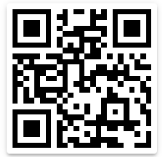
Product name :- sugar
Cost :- 30

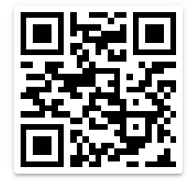

Product name :- bread
Cost :- 20

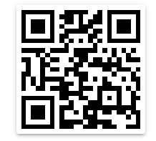

Product name :- Milk
Cost :- 50

This is OCR Reader Feature.
Name of Application is blind helper

